KHWOPA ENGINEERING COLLEGE
Eighth Semester Assessment - 2017
lEVEL:- B. E. Computer/VIII
SUBJECT:- BEG475VB, Elective–II (VB.Net C# System)
FULL MARKS:- 80
TIME:- 03:00 hrs. 2074/04/22 PASS MARKS:- 32

Candidates are required to give their answers in their own words as far as practicable.
The figures in the margin indicated full marks.

Answer any EIGHT questions.
Q.1. a) Why .net framework is required? Explain briefly. [5]

b) Explain .NET Architecture for Language and Platform Independence with labeled diagram. [5]

Q.2. a) Explain boxing and unboxing with suitable program. [5]
b) Differentiate between String and String Builder. [5]

Q.3. a) Is it possible to implement multiple inheritance in C# programming? Justify with C# program [1+4]
b) Explain procedure and function with VB example. [5]

Q.4. a) Define polymorphism. Explain function overriding with program. [2+3]

b) Mention the reasons of using Inheritance in object oriented programming? Explain single and multi-level inheritance with C# program. [2+3]

Q.5. a) Why ADO.net is required in VB.net or C# .net application? Compare ADO and ADO.Net. [2+3]

b) Differentiate between Interface and Abstract Class with suitable program example. [5]

Q.6. a) Explain different types of loops used in VB with syntax and example. [5]

b) Differentiate between checkbox control and Radio button Control with example. [5]

Q.7. a) Explain the steps to compile and build the .net program [5]
b) Define function overloading? Write C# or VB.net program to calculate area of circle, rectangle, square using function overloading. [1+4]

Q.8. a) What are the function of Data Reader and Data Set? Explain briefly. [5]

b) Write the .net code for following operation. [5]
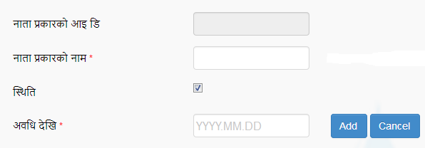

Q.9. a) Explain different Types of Standard Functions used in VB [5]
b) Define class and Constructer. Explain different types of constructer and Destructor used in object oriented programming. [2+3]

Q.10. Write short notes on any FOUR [4×2.5 = 10]
a) Dynamic Array
b) CTS
c) Structure and Enums
d) Discuss IDE of .Net Technology.
e) CLR

The End

